Name: ______________________________________ | Date: ___________________

Lesson 15: Answer Key

Part 1 Key: Cheerleading Headgear Assessment

Scoring Guidance. The elements described below would be considered an exemplary response at this point in the unit. These are shown as purple text or in purple diagrams below the related question. In some cases different elements of the response are identified with a separate + symbol These +’s are not meant to be all inclusive; they are suggestions for what you may see your students include.

If several of the ideas marked with a + are missing from a student’s response, this may indicate the student has not mastered the science ideas or that the student may be struggling to bring those ideas together in a written explanation or model. Additional probing of their thinking can provide insight about whether the student is struggling with a science practice or science idea, or both. If all or almost all of the ideas marked with a + are present in a student’s response, this may indicate the student has mastered the science ideas and is able to use them in a written explanation or explanatory model.

Protecting Athlete's Heads and Brains While Cheerleading
Many sports require or recommend helmets for protecting athletes’ heads and brains. There are helmets for biking and skateboarding, helmets for baseball and football, helmets for rock climbing, and some people are even recommending headgear for soccer players. All of these are intended to prevent damage to the head or brain in the event of a collision.

There are sports people participate in like basketball, soccer, and cheerleading where helmets or headgear are not required even though concussions and other head injuries happen often. In cheerleading, concussions are very common. At least ⅓ of all injuries in cheerleading are concussions, usually from falling or head contact with the floor. In one recent year of college sports, the cheerleaders at the University of Georgia had a higher rate of concussions than the football or soccer players. How could cheerleaders protect their heads during competition?

Watch the video with your class to see the kinds of movements that the cheerleading athletes experience.

Part 1 Here are three different headgear devices that are currently being marketed as protection from potential concussions in cheerleading.
  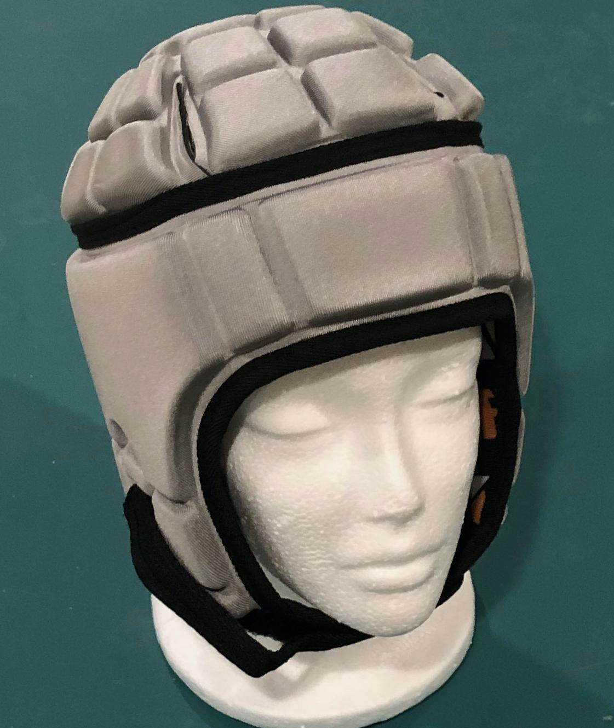
  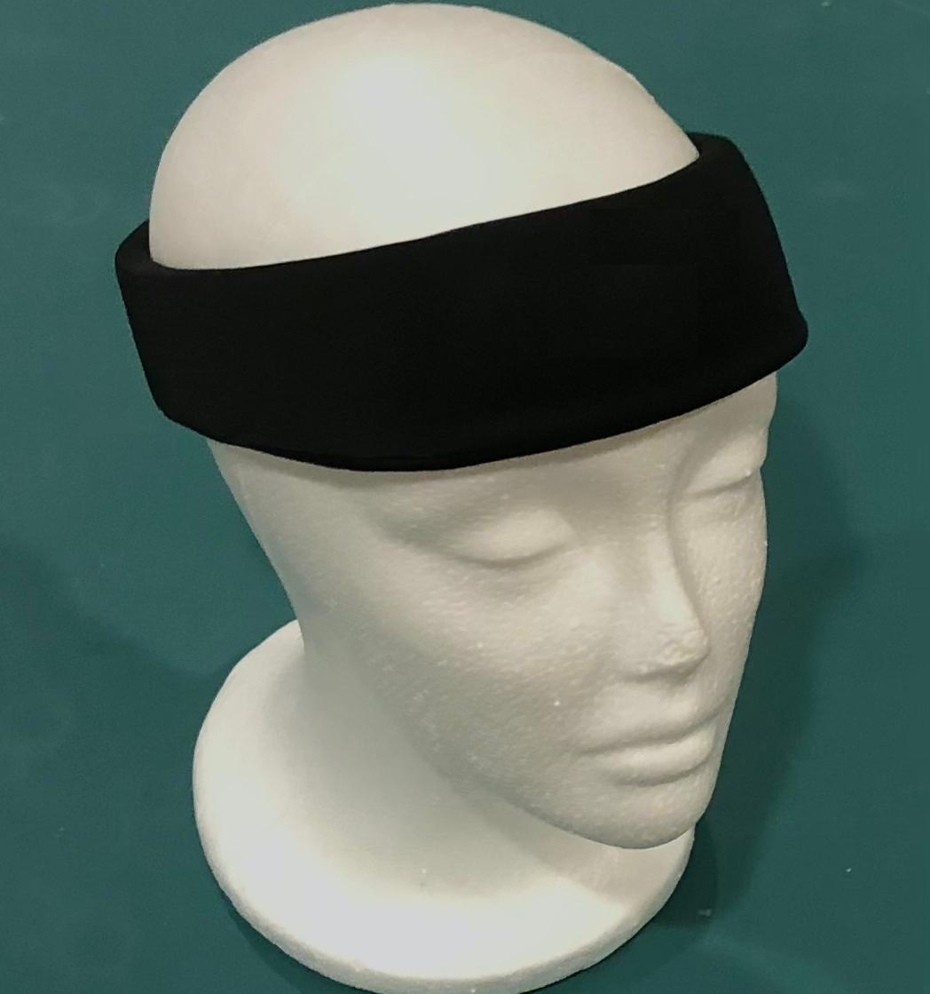
  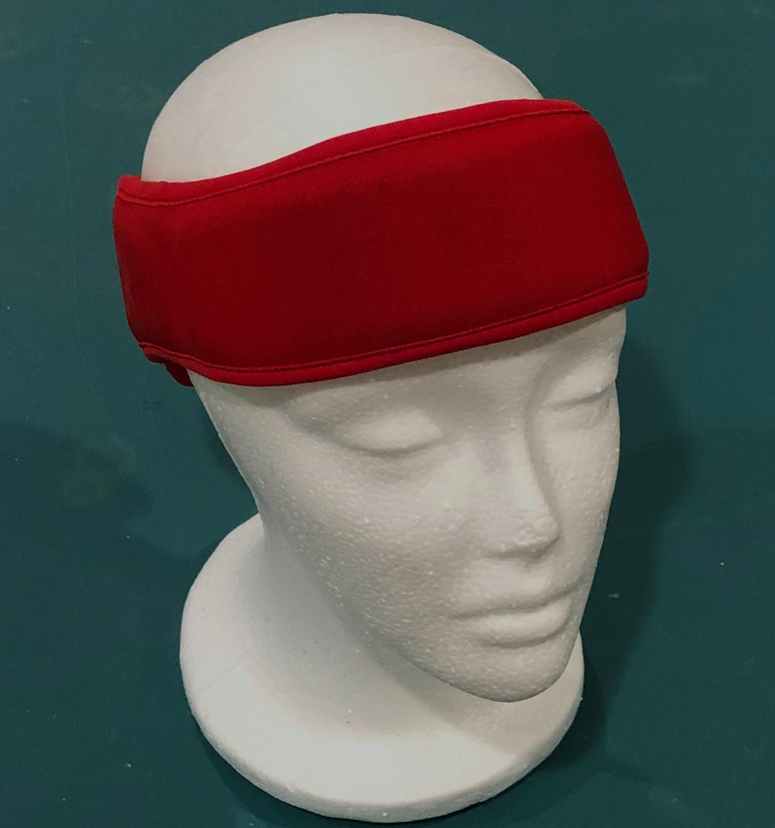
Design #1 | Design #2 | Design #3
The headgear devices shown above were initially designed for other sports, and then people started using them for cheerleading.

1a. If you were a protective headgear device designer evaluating the materials being used in another company’s design, what properties or materials would you expect to see in a good protective device if it were cut open?

+ The protective materials would have space for air.
+ The protective materials have the ability to deform a lot.
+ The protective materials might be thicker than other parts of the helmet.
+ The protective materials should be shaped so that the damaging object hits more protective material than other locations.

1b. Draw a model of the material structure you would expect to see in the design described in 1a. In your model, label each design feature. For each design feature you label, explain in words how the structural properties help it function as a protective material.

Students’ models may vary in complexity or design but should include the following types of components (e.g., space for air). Their explanations for the structural properties should be aligned to the explanations provided here:
+ Space for air. This allows the material to have more space for material deformation.
+ Ability to deform. This allows the deformed material to apply contact forces over a longer time during the collision than if there was material in that space (this provides stronger contact forces than air resistance alone).
+ Longer time where contact forces are applied. This reduces the peak forces on the objects in the system.

+ Optional
+ Thickness of cushioning material. The thicker the material is, while still being easily compressible, the more it will reduce the peak forces on the object that it is protecting
+ Shape. Different shapes provide different thicknesses and contact points: the greater the area of contact, the more distributed or spread out the forces on the protected object.

2a. When any of the designs above are worn on a person's head, the person’s head is in contact with the headgear. When a person falls to the floor and hits their head, the headgear makes contact with the ground.  Draw and label a diagram that shows all three of these objects (head, headgear, ground) in contact with each other at the point in time when the collision with the ground first starts.  Two different example student models are shown to the right.
  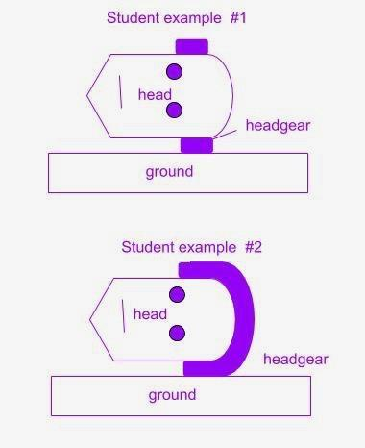

2b. Draw three free body diagrams, one for each object in your system in 2a. Include the following details in each diagram:
- Show the strength of the forces applied to each object in the system.
- Label what is applying this force to that object.
- Show the direction of these forces.
- Label the surface they are applied to.

Student example #1 in 2a is used to show one possible set of free-body diagrams below.

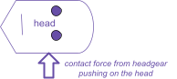  Free body diagram for the head | 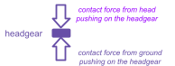  Free body diagram for the headgear |   Free body diagram for ground

Key features to look for across all three free body diagrams
+ The size and length of the force arrows are the same in all diagrams.
+ There is a single force arrow on the head against the bottom side of it and pointing upward.
+ There is a single force arrow on the ground against the top side of it and pointing downward.
+ There are two force arrows on the headgear, one against the top side of it, pointing downward, and one against the bottom side of it, pointing upward.

3a. During practice, a flyer (a person launched into the air) does not want to wear their headgear. Another member of the squad, a base (a person who launches the flyer and stays on the ground), asks the flyer to wear their headgear because it will not only protect the flyer, but it will also further protect the base if their heads collide. Do you agree or disagree with this claim?

Students can agree or disagree with this claim as long as there is an opportunity for coherent argument for their position either way as outlined below.

3b. Support or refute this claim by citing evidence from investigations we did and using any related science ideas we developed to defend your argument.

All students should include the following evidence:

If students agree (support the base person’s claim): Students must argue that there is a contact force on the head from the headband as it is compressed and makes contact with the base person.

Evidence from investigations:
During the investigation of spring scales with cushioners in between
+ Both spring scales showed the same amount of force when one spring scale pushed on another with a protective material in between.

During materials testing
+ The cushioning materials reduced peak forces on both objects in a collision (with a constant amount of kinetic energy in the system before the collision).

In the spring scale distribution demonstrations and investigations:
+ The forces were equal on both sides of the protective materials (relevant for design #2 or design #3) or
+ Optional (if students are referring to design #1): In the case where there was a cushioning material shape with surface area that was different between one surface it was in contact with versus another, it may have further reduced the amount of force on one object by spreading that force over a larger area.

Science ideas
+ Forces are distributed equally between each object making contact in a collision.
+ Materials that reduce peak forces do so on both objects they are between in a collision.
+The material can increase the time over which forces from the collision are applied to both people, which decreases the kinetic energy of the moving person (the flyer), which decreases the amount of peak force applied to each person in the system.

If students disagree (refute the base person’s claim): Students must claim that the headband does not protect the entire head, so it is possible that the two heads would collide without the headband experiencing the contact force between both heads during the collision.

Evidence from investigations
+ During materials testing
+ Some materials that were better cushioners reduced peak forces more than others.
+ But with no protective material in the middle of the collision, the peak forces will be the same with no benefit to either person.

Science ideas
+ Objects in a collision experience forces only by contact interactions with other objects.
+ If the helmet is not in contact with the ground and the head during the collision, it cannot be compressed, and therefore cannot reduce the peak forces between the two objects.

